Interactive Teaching Application

# Joseph Kellaway (10503639)

1953 words

The world around us is technologically advancing at an astonishing rate. The normal day to day life of someone doing a job on the day we are born will likely be alien to a person performing the same role on the day that we die. All aspects of our lives need to evolve and adapt to this change or face becoming obsolete and being replaced, the education system included. The education system has technology added to it, as if it is some sort of plug-in, but it never fully embraces it. This has inspired the application that I have prototyped to work as both a supplement to teaching for those in schools unwilling to change, and as a replacement to the traditional board-driven teaching for those in schools that accept the tide of technological advancement.

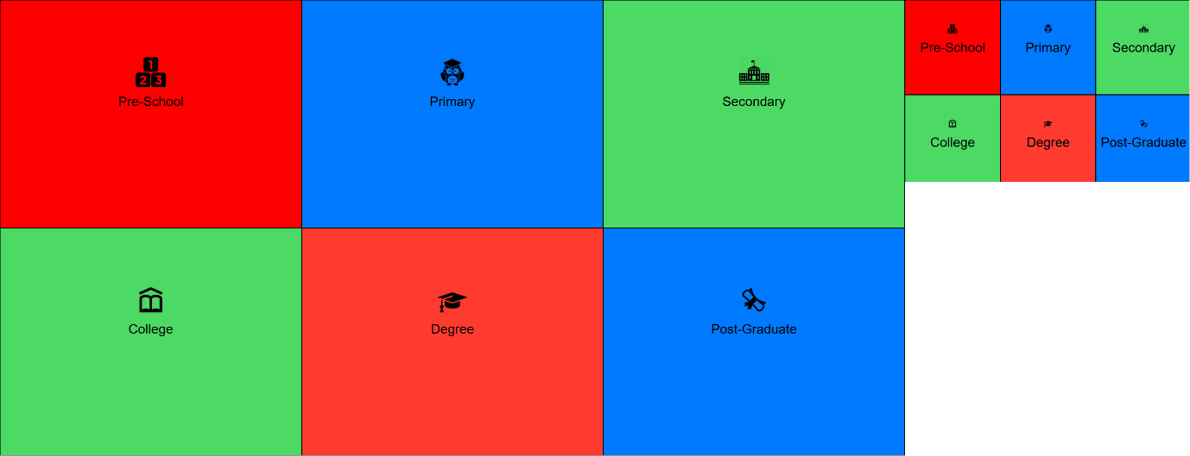The application was built from a few preliminary design sketches (see Appendix 1) and it is intended as a computer program that can be used both with an entire class through projection or using a large display, and also as an application for individual use that can be accessed on mobile devices. Central to this idea is the concept of responsive design. Responsive design dictates that a program should “resize, hide, shrink, enlarge, or move the content to make it look good on any screen” (W3schools.com, 2017). These principles have been followed in the creation of the application by using a combination of HTML and CSS, which make the output to the display shrink when the browser window itself is made smaller (see Fig. 1).

Fig. 1: The downsized window still displays the entire content of the application.

Tying in with responsive design is the idea of user experience (UX), which states that the product must have “simplicity and elegance that produce products that are a joy to own, a joy to use” (Norman and Nielsen, 2017). These principles were followed by using the same menu on different devices, but also maintaining an identical style for each individual menu (see Fig. 2). By doing this the application “strives for consistency” (Shneiderman et al, 2016) and combined it allows for “the limitation of human information processing in short-term memory” (Shneiderman et al, 2016). Meaning that if the user accidentally clicks the incorrect option, they will not be confused about how to navigate back to the previous menu.

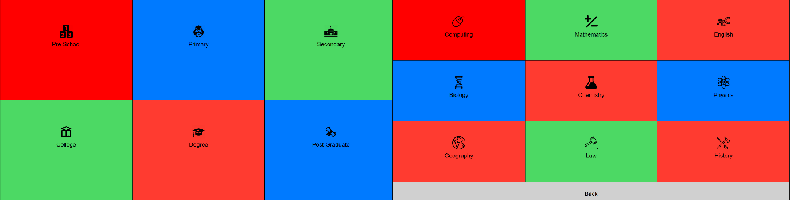After designing the menu layout, the next point to determine was the colour scheme. Considering that in computing terms all colours are created using red, green, and blue, and Apple suggest using a “limited color palette” (Apple, 2017), a tri-colour scheme of these colours was implemented. The colours chosen needed to have an obvious difference between each other, both when dormant and when the user ran the mouse cursor over them, in order to draw attention to which option was being selected to “offer informative feedback” (Shneiderman et al, 2016). This meant that a dull/pastel and a bright version of each colour would be required. The dormant colours should then in turn meet the “minimum contrast ratio of 4.5:1” (W3.org, 2017) for users to easily read the text colour. These contrasts were measured using a contrast calculator[1].

Fig. 2: The menu to pick the education level and the submenu to pick the subject are the same style, with the exception of the “back” button to return to the main menu.

Finally, the menu order was decided based upon order to be accessed (i.e. the different levels of schooling are in chronological order), and then related subjects are adjacent to each other, for example, the three sciences. An easily-recognisable image associated with each option was used to provide the user with assistance in finding their desired choice, based on the theory that humans form innate associations and that "human cognition is unique in that it has become specialized for dealing simultaneously with language and with nonverbal objects and events.” (Paivio, 1986, p.53).

With the menu and navigational systems in place and scalable, focus then moved on to the quiz itself. To maintain “consistency and standards” (Nielsen, 1995), the choices were narrowed down to the three colours chosen for the menu system. Blue was the final choice as it portrays a message of “loyalty, integrity and trustworthiness” (Sutherland and Karg, 2004) and is less likely to cause a strain on the user’s eyes, as brighter colours such as red and green can become “tiring to look at” (Stone, 2005).

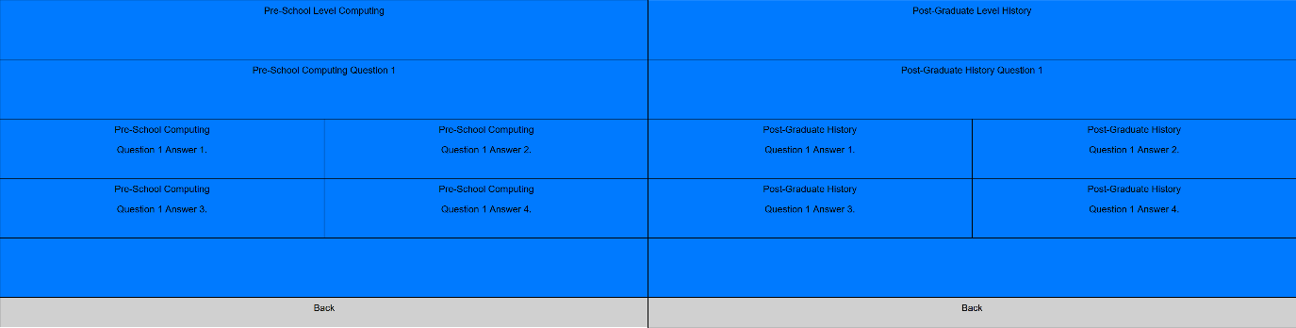

Fig. 3: Different age and subject quizzes have the same standard layout.

Sticking to the same scheme as the menu system, the quizzes are easily recognisable as part of the application, irrespective of which course has been chosen. This allows frequent users to have an “increased pace of interaction” (Shneiderman et al, 2016) when changing between courses and course levels since the interactions are the same, thus leaving more time for the user to focus on learning content rather than how to access it. The “back” button also retained the same colour, size, and reaction when the user cursors over it, which offers the user an obvious “easy reversal of actions” (Shneiderman et al, 2015).

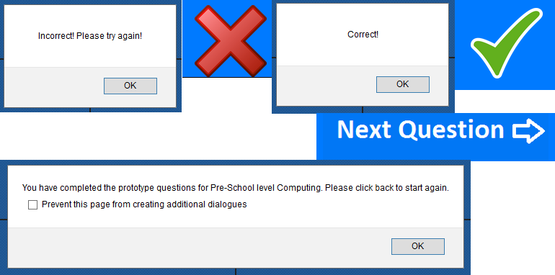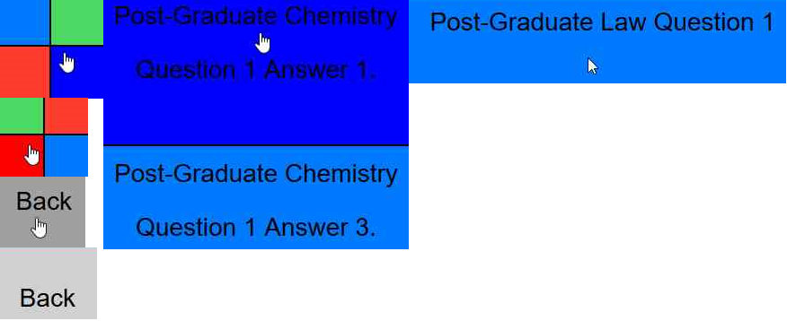Throughout the application, the same “informative feedback” (Shneiderman et al, 2016) is given when the user moves their mouse cursor over anything that is interactive (see Fig. 4). The cursor changes from the standard arrow-head shape to a hand pointing a finger, and the colour is made brighter to draw attention away from the other objects on the screen and towards the clickable area.

Fig. 5: Visibility of system status and informative feedback are constantly fed back to the user as questions are answered.

Fig. 4: Cursor and colour change when something is interactive.

This informative feedback is expanded upon when the user is using the application to test their knowledge on a subject by giving “visibility of system status” (Nielsen, 1995). The upper left message box and red cross (see Fig. 5) appear when the user selects the incorrect answer, the upper right message box, green tick, and option to move on to the next question appear when the user selects the correct answer, and when the user has exhausted all of the questions available for that subject at that level, the bottom message box is shown. The prototype shows 10 questions for each subject at each schooling level, though the finished product would extract the questions and their answers from a database and this would be as high or as low as the number of questions in the database.

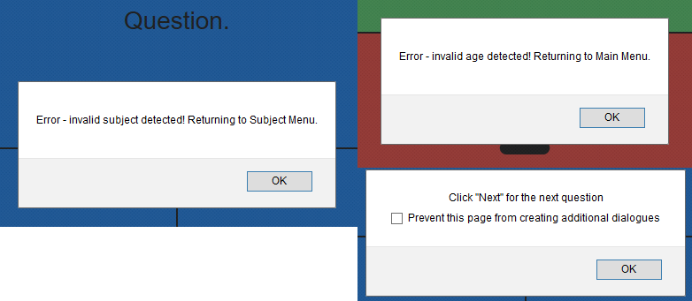An issue that every good program must try to control is the creation and handling of errors. Research suggests that the creator should “design the system so the user cannot make a serious error. If an error is made, the system should be able to detect the error and offer simple, comprehensible mechanisms for handling the error” (Shneiderman et al, 2016). This has been thoroughly attempted throughout the prototype through the passing of variables and displaying alert messages before crucial points if the variable flags the known error. Below are examples of some of the errors that the prototype is protected against and the feedback that the user receives to inform them of what is happening. The quiz page is also protected against an invalid age being provided, but it catches the invalid subject first and so it flagged that error instead. The bottom right message box is shown when the user attempts to submit an answer after already submitting the correct answer to the question.

Fig. 6: Error handling within the application.

To advance beyond the current prototype stage, user-testing would be required to ensure that time (and therefore money) isn’t wasted in creating a product that simply doesn’t do the job that it is designed to do. Given the varied nature of both the ages and interests of the targeted users of the application, thorough trialling would be required to ensure that it is effective across all areas. This trialling would guarantee that a pre-school aged child learning how to spell could use the application to learn more efficiently than they would normally do, and at the same time it would improve the studying efficiency of a post-graduate computer science student, and a teacher would still be able to distribute information to their classroom effectively.

Each type of user-centred evaluation technique has its own advantages and disadvantages, most of which are either cost related, the effectiveness of the evaluation and its likelihood of providing accurate information, or simply the type of data that is returned. Since the age and interests of the target users are so varied, there is room for numerous different types of tests to be effective.

Producing a survey (for proposed survey see Appendix 2) to gauge how effective the interface is could potentially be an effective way to gain a quick insight in to the users’ thoughts and opinions on the program. Due to the variety of ages necessary to connect with, it may be more effective at collecting feedback on negative attributes from adult users who are more likely to reply with an honest, slightly more critical view of a piece of technology being moved into their workplace, and collecting feedback on the positive aspects of the system from younger users who would be likely to experience the introduction of a piece of technology to their learning environment as a positive, exciting thing.

Observing and monitoring users and the system would be an effective way to improve it once full implementation has begun. Given each user will have a different technological expertise level, the way that the adult user interacts with the interface may be more (or less) efficient than the child user. This would give more qualitative feedback than the survey, since additional to simply measuring the time required to perform a task whilst using the application, the observer can monitor other conditions too. These include determining whether body language suggests negative feeling towards it, or directly asking for feedback in an interview scenario afterwards. The main issue with observation would be that for ethical purposes the individuals would have to be aware that they are being monitored, which may have an impact on their behaviour whilst they are working.

Experiments and benchmarking would be useful for extracting quantitative data about the application, however, they are expensive to carry out and the users would be under pressure to perform, which may affect the validity of the information. This is particularly true of children who aren’t used to working under pressure.

Interpretive and predictive evaluations would be acceptable for some scenarios but not others. Organising these evaluations with college age and over would be reasonably straight forward, but having access to a school classroom using the application would be difficult. Working with individuals in their own time may be acceptable, but disrupting a classroom would have a negative impact on learning, which is the exact opposite of what the application is aimed at achieving.

Overall I feel that the application has a good base structure to work from. If the correct database is acquired to populate the quiz, and with the right improvements made based on user feedback, it has the potential to transform the learning environment. Focusing improvements mainly on the younger user’s feedback may be a more effective way of improving the product since in time the child user will become the adult user, and will likely be more efficient at using the interface when performing the same roles as the current ones. Initial surveys alongside observation/monitoring would be beneficial in improving the application, with a further survey when a wider user-base has had access to the application to gauge faults found by a larger number of users.

## References

Apple, (2017). *Color - Visual Design - iOS Human Interface Guidelines*. Available at: <https://developer.apple.com/ios/human-interface-guidelines/visual-design/color/> [Accessed 16 Jan. 2017].

Nielsen, J., (1995). *10 Heuristics for User Interface Design.* Available at: <https://www.nngroup.com/articles/ten-usability-heuristics/> [Accessed 16 Jan. 2017].

Norman, D. and Nielsen, J. (2017). *The Definition of User Experience (UX)*. Available at: <https://www.nngroup.com/articles/definition-user-experience/> [Accessed 15 Jan. 2017].

Paivio, A., (1986). *Mental representations*. 1st ed. New York: Oxford Univ. Pr. [u.a.], p.53.

Shneiderman, B., Plaisant, C., Cohen, M., Jacobs, S., and Elmqvist, N., (2016). *Designing the User Interface: Strategies for Effective Human-Computer Interaction.* 6th ed. Harlow, United Kingdom: Pearson Education. Section 3.3.4.

Stone, D. (2005). *User interface design and evaluation*. 1st ed. Amsterdam: Morgan Kaufmann. p.254.

Sutherland, R. and Karg, B. (2004). *Graphic Designer’s Color Handbook.* Gloucester, MA.: Rockport Publishers. p.19.

W3 (2017). *Understanding Success Criterion 1.4.3 | Understanding WCAG 2.0*. Available at: <https://www.w3.org/TR/UNDERSTANDING-WCAG20/visual-audio-contrast-contrast.html> [Accessed 17 Jan. 2017].

W3schools, (2017). *HTML Responsive Web Design*. Available at: <http://www.w3schools.com/html/html_responsive.asp> [Accessed 14 Jan. 2017].

# Icon References

Pre-School

https://cdn0.iconfinder.com/data/icons/education-learning/128/123-blocks2-512.png

Primary

https://cdn1.iconfinder.com/data/icons/education-39/100/08-512.png

Secondary

https://cdn3.iconfinder.com/data/icons/school-solid-icons-vol-1/96/001-512.png

College

https://maxcdn.icons8.com/Share/icon/Science//school1600.png

Degree

https://cdn0.iconfinder.com/data/icons/pixel-perfect-at-24px-volume-2/24/2010-512.png

Post-Graduate

http://downloadicons.net/sites/default/files/diploma-icon-86826.png

Computing

https://www.shareicon.net/computer-mouse-interface-pointer-computer-643738

Mathematics

https://www.shareicon.net/mathematics-symbols-maths-sign-plus-minus-slash-symbol-signs-673853

English

https://www.shareicon.net/alphabet-vowel-consonant-643705

Biology

https://www.shareicon.net/laboratory-medical-biology-science-736642

Chemistry

https://www.shareicon.net/lab-chemistry-science-chemical-laboratory-education-726124

Physics

https://www.shareicon.net/science-education-physics-electron-733117

Geography

https://www.shareicon.net/geography-planet-earth-maps-and-flags-global-worldwide-781110

Law

https://www.shareicon.net/law-596041

History

https://www.shareicon.net/weapons-axe-blade-sword-748555

Tick

https://cdn.pixabay.com/photo/2016/03/31/14/37/check-mark-1292787_960_720.png

Cross

https://cdn.pixabay.com/photo/2012/04/13/00/22/red-31226_960_720.png

Appendix 1

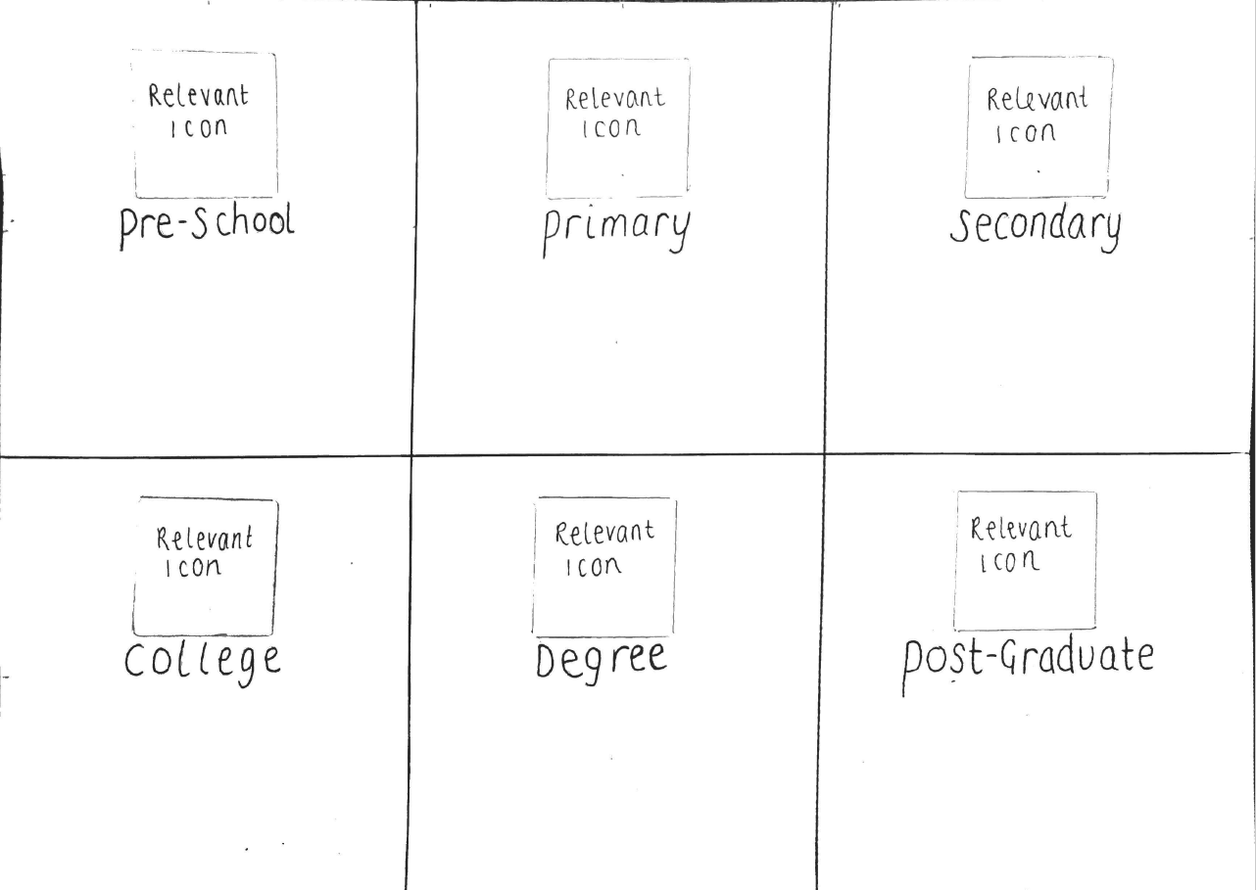

Main menu design sketch.

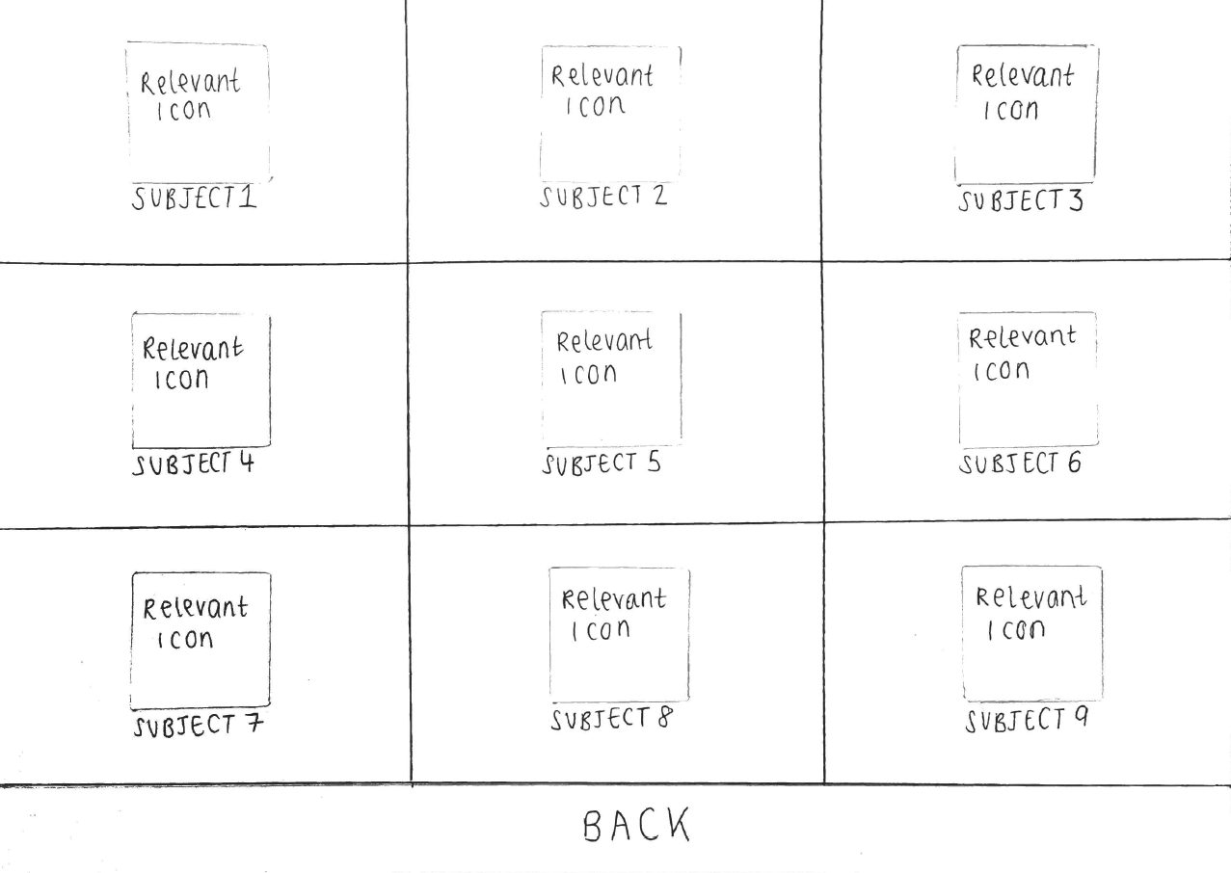Submenu design sketch.

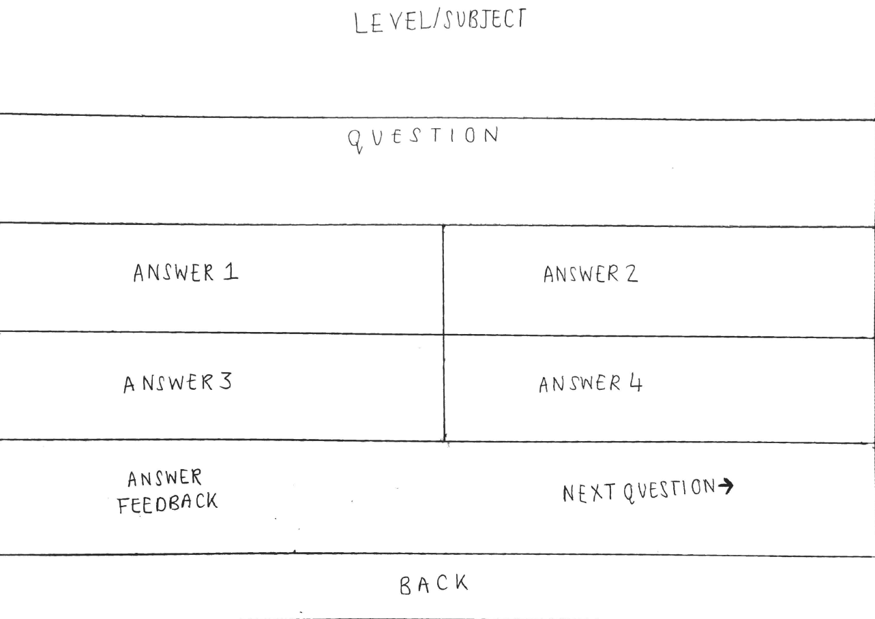

Quiz design sketch.

Appendix 2

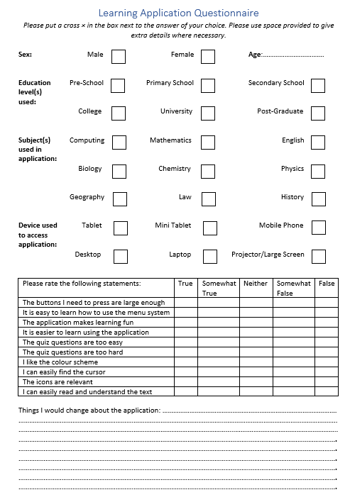

Proposed evaluation questionnaire.

1. <http://webaim.org/resources/contrastchecker/>